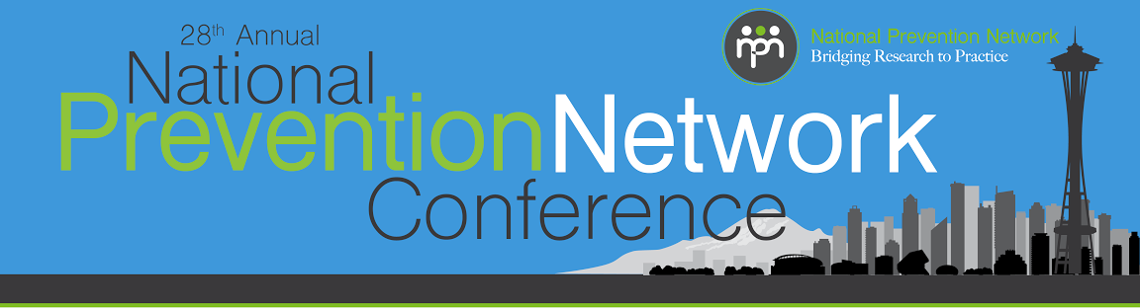

CADCA’s National Youth Leadership Initiative Training
Location: Cirrus Room, 35th Floor

Tuesday, November 17
7:30 – 8:15 am Breakfast
8:15 – 9:00 am Prepare for the Day and Clean Breakfast
9:00 – 10:15 am Welcome and Introductions
9:45 – 10:15 am Adult Advisors Orientation, Jefferson, 4th Floor (separate room)
10:15 – 10:45 am Break
10:45 – 11:00 am NYLI Overview
11:00 – 12:00 pm Leadership Principles and Cultural Competence
12:00 – 1:30 pm Lunch
1:30 – 2:15 pm The History of Prevention and Strategic Prevention Framework (SPF)
2:15 - 3:00 pm Community Assessment
3:00 – 3:30 pm Break
3:30 – 4:15 pm Community Assessment (Continued)
4:30 – 6:00 pm General Conference Reception, Grand Ballroom Foyer, 2nd Floor (separate room)

Wednesday, November 18
7:30 – 8:15 am Breakfast
8:15 – 9:00 am Prepare for the Day and Clean Breakfast
9:00 – 9:30 am Recap Day 1 and Energizer
9:30 – 10:00 am AHE
10:00 – 10:30 am Break
10:30 – 11:30 am Risk Factors
11:30 – 12:00 pm Local Conditions
12:00 – 1:30 pm Lunch
1:30 – 2:00 pm Energizer
2:00 – 3:00 pm Logic Model
3:00 – 3:30 pm Break
3:30 – 4:30 pm Interventions
4:30 – 5:15 pm Evaluation

Thursday, November 19
7:30 – 8:15 am Breakfast
8:15 – 9:00 am Prepare for the Day and Clean Breakfast
9:00 – 9:15 am Recap Day 2 and Energizer
9:15 – 10:00 am Action Planning
10:00 – 10:20 am Break
10:20 – 11:00 pm Youth In Action Projects
11:00 – 12:00 pm Youth in Action Oral Presentations
12:00 – 12:30 pm Wrap Up/Participant Evaluations
12:15 – 12:30 pm Advanced Youth Presentation (separate room)
12:30 – 1:30 pm Lunch/Dismissed

